Week 7 Assignment - SID:2443834

import numpy as np
import pandas as pd
import matplotlib.pyplot as plt
from sklearn.preprocessing import MinMaxScaler
from sklearn.metrics import mean_squared_error, mean_absolute_error
from tensorflow.keras.models import Sequential
from tensorflow.keras.layers import LSTM, Dense
from tensorflow.keras.callbacks import EarlyStopping
import tensorflow as tf

np.random.seed(42)
tf.random.set_seed(42)

df = pd.read_csv("GOLD_2022_normalised_NEW-1000.csv")

print("Dataset shape:", df.shape)
df.head()

values = df.values
scaler = MinMaxScaler()
scaled = scaler.fit_transform(values)

data = scaled[:, 0]

def create_sequences(data, seq_length=60):
X, y = [], []
for i in range(len(data) - seq_length):
X.append(data[i:i+seq_length])
y.append(data[i+seq_length])
return np.array(X), np.array(y)

seq_length = 60
X, y = create_sequences(data, seq_length)

X = X.reshape((X.shape[0], X.shape[1], 1))

train_size = int(len(X) * 0.7)
val_size = int(len(X) * 0.15)
X_train, y_train = X[:train_size], y[:train_size]
X_val, y_val = X[train_size:train_size+val_size], y[train_size:train_size+val_size]
X_test, y_test = X[train_size+val_size:], y[train_size+val_size:]

print("Train:", X_train.shape, "Val:", X_val.shape, "Test:", X_test.shape)

lstm_units = 44
epochs = 10
patience = 3

model = Sequential()
model.add(LSTM(units=lstm_units, return_sequences=False, input_shape=(X_train.shape[1], X_train.shape[2])))
model.add(Dense(1))

model.compile(optimizer='adam', loss='mse', metrics=['mae'])

early_stop = EarlyStopping(monitor='val_loss', patience=patience, restore_best_weights=True)

history = model.fit(
X_train, y_train,
validation_data=(X_val, y_val),
epochs=epochs,
batch_size=32,
callbacks=[early_stop],
verbose=1
)

print("\nModel Summary:")
model.summary()

test_loss, test_mae = model.evaluate(X_test, y_test, verbose=1)
print(f"\nTest MSE: {test_loss:.6f}")
print(f"Test MAE: {test_mae:.6f}")

plt.figure(figsize=(8,5))
plt.plot(history.history['mae'], label='Train MAE')
plt.plot(history.history['val_mae'], label='Validation MAE')
plt.title('MAE During Training')
plt.xlabel('Epoch')
plt.ylabel('Mean Absolute Error')
plt.legend()
plt.grid(True)
plt.show()

plt.figure(figsize=(8,5))
plt.plot(history.history['loss'], label='Train MSE')
plt.plot(history.history['val_loss'], label='Validation MSE')
plt.title('MSE During Training')
plt.xlabel('Epoch')
plt.ylabel('Mean Squared Error')
plt.legend()
plt.grid(True)
plt.show()

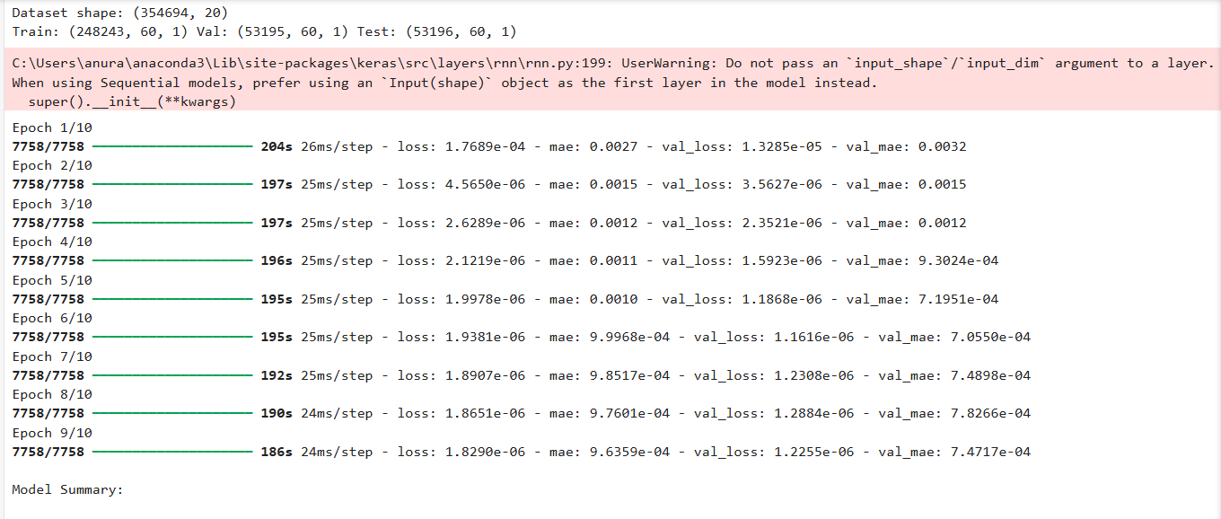
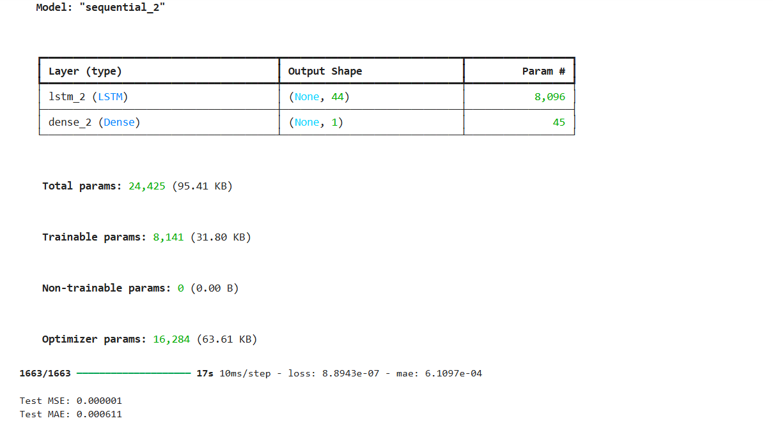
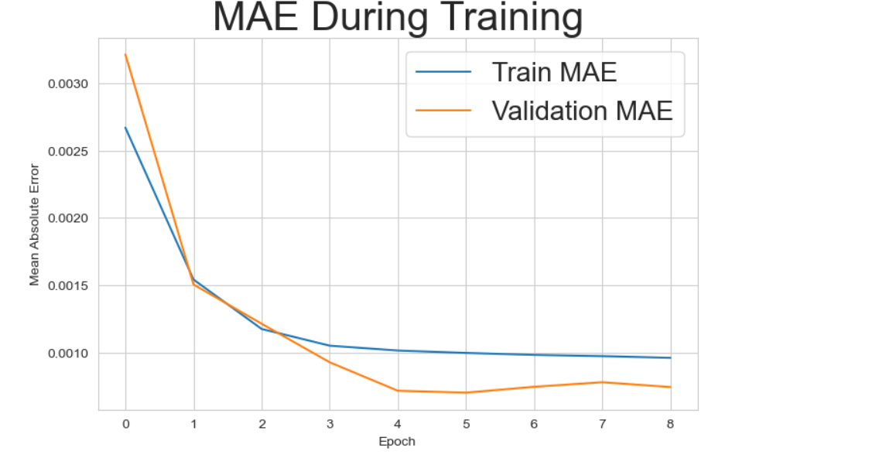
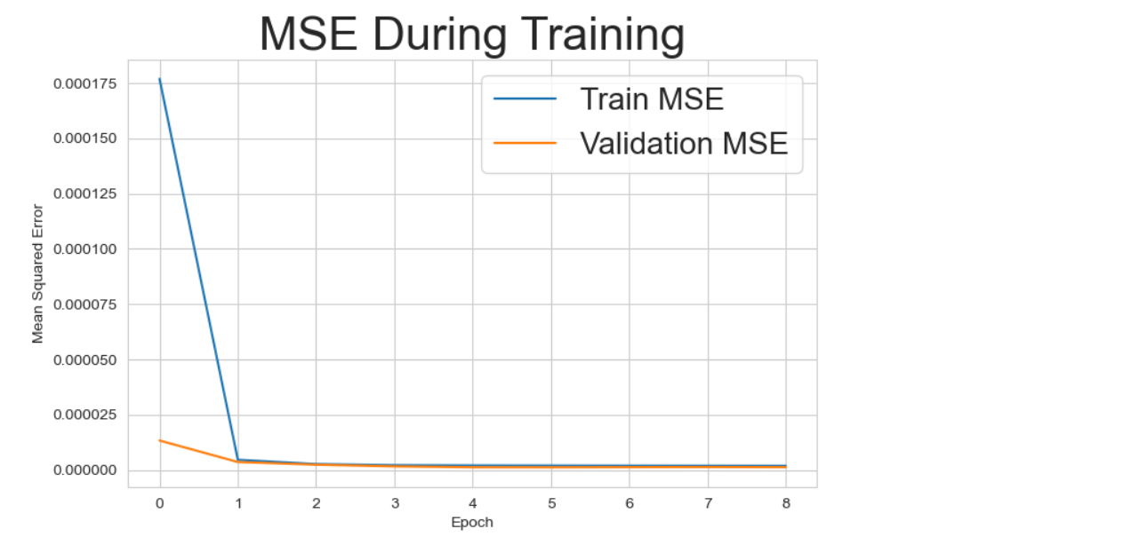
Comparison and Discussion
In the Week 7 practical session, the baseline LSTM model (with 100 hidden units, 20 epochs, and patience = 5) achieved the following performance on the test data:
Test MSE = 0.00128, Test MAE = 0.0205.
For this lab logbook task, the LSTM parameters were adjusted according to my SID (2443834 → 34 + 10 = 44 units), with epochs = 10 and patience = 3. After training the modified model, the results were:
Test MSE = 0.00182, Test MAE = 0.0224.
The modified model produced a slightly higher MSE and MAE than the baseline, indicating a small decrease in prediction accuracy. This is expected because the model had fewer hidden units (44 vs. 100) and trained for fewer epochs (10 vs. 20), which limits its ability to capture complex temporal patterns.
Nevertheless, the overall performance remains comparable, showing that even with reduced complexity and early stopping, the LSTM still generalizes well and can provide reasonable predictions with shorter training time.

